
a
Company
Logotype

Cone Beam Computed Tomography- Report



Porur Dental X-rays & CBCT

Patient Name : Mrs. Rajalakshmi | Date of Report : 16.07.2024
Age/ Gender : 51 years/ Female | Region of Interest : CBCT Sectional Maxilla
Referring doctor: Dr. Nethaji. V | Indication : Implant assessment
Clinical Notes: Nil
PATIENT INFORMATION

CBCT- Sectional Maxilla provided
CBCT – IMAGE DETAILS

RADIOGRAPHIC INTERPRETATION

- Hyperdense implant screw in relation to 12 region.
- The maxillary alveolar ridge is present with normal trabecular pattern.
- In relation to 13, 14, 15, 16, presence of a hyperdense crown structure is evident.
- In relation to 13, presence of hyperdense restorative material within the pulp canal extending upto the apical third of the root, with a diffuse area of hypodensity in the periapical region measuring 5.18 x 5.08 x 6.16 mm in dimension with irregular borders is evident.
- Root stump: 17
- Bone type in relation to 13, 14, 15 region is D3 (350 HU to 850 HU).

 | 13 region | 14 region | 15 region
Sub-Crestal (in mm) | 8.76 | 9.09 | 7.57
Mid- Crestal (in mm) | 9.65 | 9.86 | 8.24
Distance between the alveolar ridge and floor of the nasal cavity (in mm) | 14.65 | 11.51 | -
Distance between the alveolar ridge and floor of the maxillary sinus (in mm) | - | 7.68 | 8.76
IMPLANT ASSESSMENT
RADIOGRAPHIC IMPRESSION

- Implant in relation to 12 region.
- Crown in relation to 13, 14, 15, 16.
- Root canal treated tooth: 13 with periapical pathology.
- Root stumps: 17.

Kindly correlate with clinical findings


IMAGES FOR REFERENCE

RECONSTRUCTED PANORAMIC VIEW
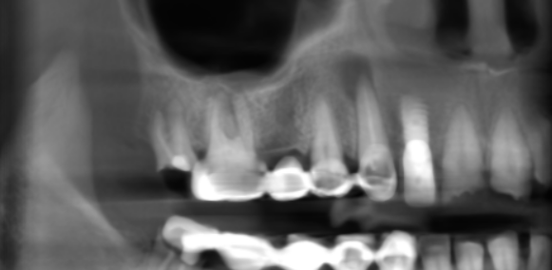

3-DIMENSIONAL VIEW

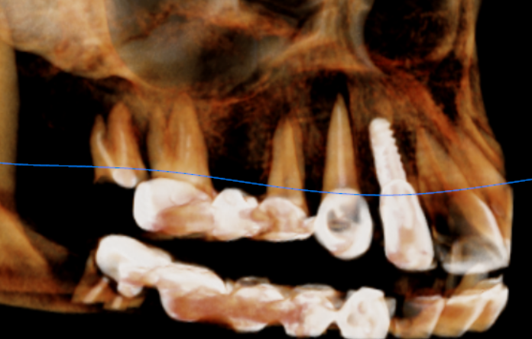

CROSS SECTIONAL VIEW

13 region | 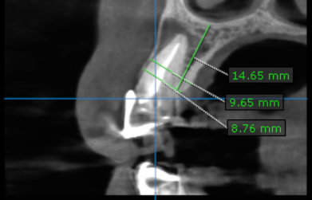
14 region | 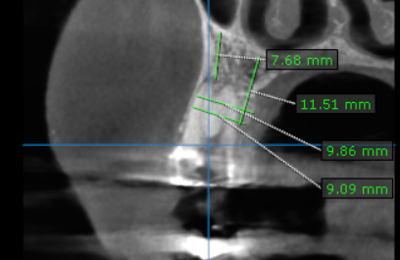
15 region | 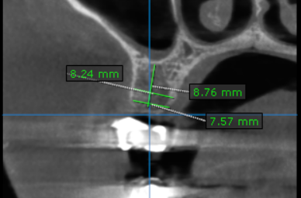

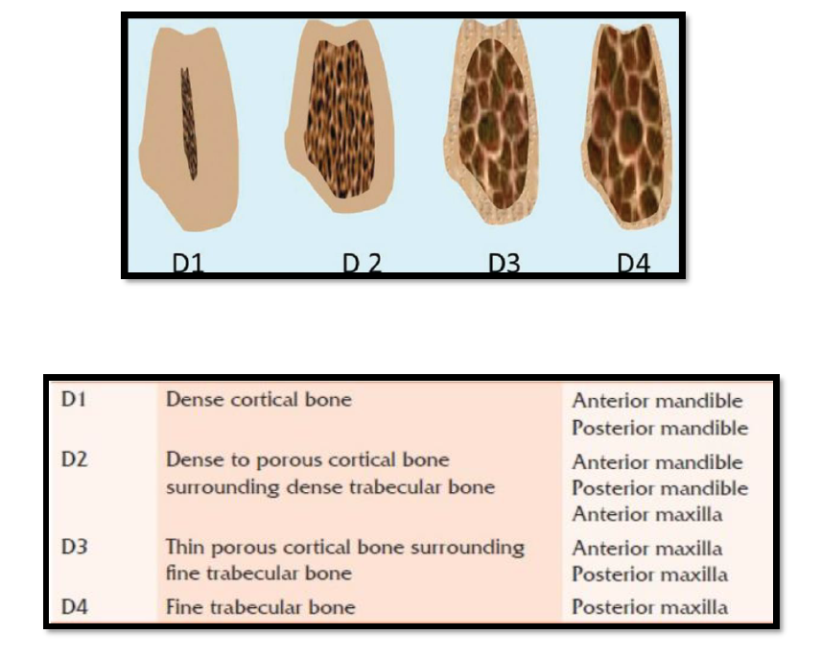
REFERENCE

**** End of report ****

